|  |
| --- |
|   **APG TS17 START BLOCK**  **SITE MEASUREMENTS** |

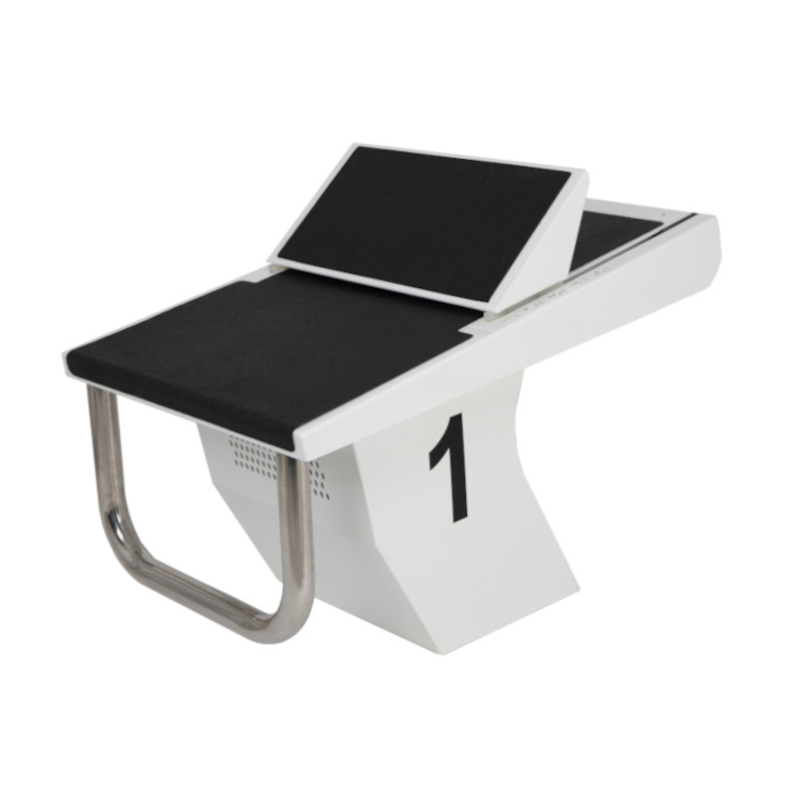

**GENERAL ORDER DETAILS**

|  |  |  |
| --- | --- | --- |
| **FACILITY/CLUB NAME:** |  |  |
| **SITE ADDRESS:** |  |  |
| **CLIENT NAME:** |  |  |
| **CLIENT CONTACT NUMBER:** |  |  |
| **BLOCK TYPE:** | TS17 START BLOCK  / TS19 START BLOCK |  |
| **POOL TYPE:** | Raised End |  |
| **FIXINGS:** | New |  |
| **GRIP PLATE COLOUR:** | Black |  |
| **START BLOCK COLOUR:** | White |  |
| **START BLOCK NUMBERING:** | 0 / 1 / 2 / 3 / 4 / 5 / 6 /7 / 8 / 9 |  |
| **DATE COMPLETED:** |  |  |
| **CUSTOM MODIFICATION REQUIRED:** | No |  |
|  |  |  |
| **APG APPROVED BY & DATE:** |  |  |

|  |  |  |
| --- | --- | --- |
| **EXISTING POOL DETAILS** | | |
| **DEPTH AT DEEP END:** | Dimension in cm |  |
| **DEPTH AT SHALLOW END:** | Dimension in cm |  |
| **OVERFLOW CHANNEL:** | Yes / No |  |
| **DROP TO WATER IF APPLICABLE:** | Dimension in cm |  |
| **DEPTH OF UPSTAND:** | Dimension in cm |  |
| **POOL EDGE TO FRONT OF OVERFLOW CHANNEL:** | Dimension in cm **** See Figure 1 on rear pages **** |  |
| **POOL EDGE TO BACK OF OVERFLOW CHANNEL:** | Dimension in cm **** See Figure 2 on rear pages **** |  |
| **GRADIENT OVER 80CM:** | Dimension in cm **** See Figure 3 on rear pages **** |  |
| **GRADIENT DIRECTION:** | Gradient falls towards the pool edge / Gradient falls away from the pool edge |  |
| **ARE THERE ANY OBSTRUCTIONS OR THINGS WHICH MAY CAUSE AN ISSUE:** |  |  |
| **SKETCH OF POOL EDGE IF NEEDED:** |  |  |

**EXISTING FIXING DETAILS**

|  |  |
| --- | --- |
| **NUMBER OF FIXINGS PER BLOCK:** |  |
| **THREAD SIZE IF KNOWN:** | M8 / M10 / M12 |
| **DIMENSION OF HEX BOLT TOP:** |  |
| **DIAMETER OF HEX THREAD BASE:** |  |

**PLAN VIEW OF START BLOCK**

|  |  |  |  |  |  |
| --- | --- | --- | --- | --- | --- |
| **POOL LANE** | **A** | **B** | **C** | **D** | **E** |
| **1** |  |  |  |  |  |
| **2** |  |  |  |  |  |
| **3** |  |  |  |  |  |
| **4** |  |  |  |  |  |
| **5** |  |  |  |  |  |
| **6** |  |  |  |  |  |
| **7** |  |  |  |  |  |
| **8** |  |  |  |  |  |

**Additional guidance notes**: also see <https://youtu.be/R17YKdLK8OY> online for further guidance via YouTube video.

|  |
| --- |
| **PLEASE INSERT OR INCLUDE PHOTOS WITH THIS DOCUMENT OF YOUR POOL EDGE, EXISTING FIXINGS AND BLOCKS IF APPLICABLE** |

**FIGURE 1 FIGURE 2**

**FIGURE 3**

Place the rear of the level appx 80cm back from the pool edge, lift until the bubble is in the centre and then take the measurement between the bottom of the level and the tiles as shown below:

