Technical Data Sheet
Vileda Professional
Freudenberg Home and Cleaning Solutions, Im Technologiepark 19, D-69469 Weinheim
www.vileda-professional.com
UltraSpeed Pro r-MicroLite Max mop

International article number Product classification
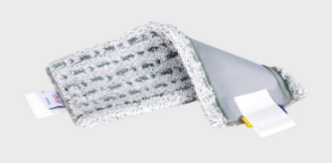
173420 (40 cm, CC) Flat mopping
Fibre composition
100% Polyester
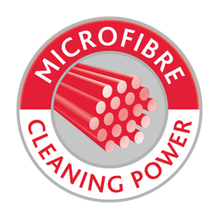
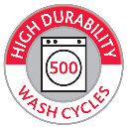
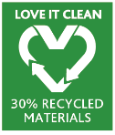
Technical data
MIN. 35% RECYCLED
MATERIALS
 | Typical value | Unit
Weight per 40 cm mop | 95 | g
Absorption capacity | 290 | %
Product properties and application
- Single sided highly effective and easy gliding microfibre mop
- To be used with UltraSpeed Pro frames
- Microfibre technology for optimum durability and cleaning performance without aggressive chemicals
- All over scrubbing islands to loosen sticky dirt
- XL mop construction with symmetric cleaning lips on long mop side for perfect corner and skirting board cleaning
- Mono-material, 100% recyclable containing 35% recycled polyester
- Up to 99.99% virus removal tested with Bovine coronavirus on vinyl surfaces at a 3rd party lab
- Up to 99.99% bacteria removal tested with P. aeruginosa & S. aureus on vinyl surfaces at a 3rd party lab
- User-friendly I-strip mop attachment
- With R/B/G/Y colour code tags for identification and individual adaptation to hygiene systems
- Durability up to 500 washes tested at internal lab with chemical-thermal disinfection at 60°C
- For general cleaning of sealed or smooth surfaces and specialist on structured vinyl floors
- Suitable for bucket press cleaning
- Made in Europe
Washing recommendation
- Ideal conditions: 60°C, avoid high alkalinity and strong bleaching activity (do not use chlorine bleach),
wash with similar colours
- Maximum washing temperature: 95°C
Storage, disposal and end-of life
Keep palletized products in a cold and dry place. Avoid exposure to direct sunlight. Product is not subject to transportation regulations for hazardous substances or chemicals. Disposal via landfill or incineration possible, please respect local regulations. This product is composed out of one single material, and thus is designed for material recycling.
Quality assurance / Compliance with international standards
This product is compliant to our internal quality standards and external regulations.

Date: 2023/11/13
All information contained herein is given on an “AS IS” basis and based on our current knowledge. NO WARRANTY, WRITTEN OR ORAL, EXPRESSED OR IMPLIED IS GIVEN BY US OR MAY BE INFERRED FROM A COURSE OF DEALING OR USAGE OF TRADE NEITHER BASED ON ADVERTISEMENTS, CONCLUDING ACTION NOR COMMERCIAL USE. TO THE EXTENT ALLOWED BY LOCAL LAW WE DISCLAIM ALL IMPLIED WARRANTIES OR CONDITIONS INCLUDING ANY IMPLIED WARRANTIES OF MERCHANTABILITY AND FITNESS FOR A PARTICULAR PURPOSE, AND WARRANTIES OF NON-INFRINGEMENT. Technical data are typical values and subject to a certain tolerance and variations and can be changed without further prior notice. Solely the customer shall be responsible to assess the suitability of our products for any intended USES as well as ALL relevant health, safety and environment properties AND RISKS.
Vileda Professional
Freudenberg Home and Cleaning Solutions GmbH, Im Technologiepark 19, D-69469 Weinheim
www.vileda-professional.com

